**Gospel Outreach and Mission**

**Overview**

A Sunday school workshop was held on 29 July 2018 in Wilkie. The central theme was on proclamation of the gospel of the kingdom and mission (Mt 24:14). The Sunday school gathered in small group and Sunday school teachers facilitated the discussion. Thoughts on prayers, preparations and programmes in our assembly on the gospel outreach and mission were exchanged. The groups shared their experiences on the outreach to the foreign workers in Singapore, among the Chinese and non-Chinese speaking nationals. There were briefings and updates for mission trips in the region - Malaysia, Cambodia and Indonesia. The discussions were lively and we thank God, for giving us a heart for the gospel outreach and mission. This short article is to encourage one another on the challenges and opportunities in evangelism, reflect on the calling and prayer needs for the gospel outreach and mission. This thought paper is written to engage the readers with hard questions as active co-labourers in the harvest field.

**From the church camp to the pulpit**

Following the 2018 June camp with the theme verse “*For I feel a divine jealousy for you, since I betrothed you to one husband, to present you as a pure virgin to Christ*.” (2 Cor 11:2), our brother Jonathan Pong spoke passionately on the Gospel of the Kingdom. Jesus came as King of the Jews. He wanted to be your king and mine. A Kingdom of heaven not this earth. Proclamation of the Gospel of the Kingdom was passed on to the responsibility of His disciples. (Mt 4:19). Do we treat the word of God as commandments to obey? “*But you will receive power when the Holy Spirit has come upon you, and you will be my witnesses in Jerusalem and in all Judea and Samaria, and to the end of the earth*.” (Acts 1:8). We can start by sharing the gospel locally and in the neighbouring countries. The Sunday school workshop took on the challenge to focus on gospel outreach and mission during the 29 July 2018 workshop with the theme, “*And this gospel of the kingdom will be proclaimed throughout the whole world as a testimony to all nations, and then the end will come*” (Mt 24:14).

**From the word to prayer**

**Prayer** and the work of God. Jesus fulfilled his mission through prayer. The Bible speaks of prayer in watchfulness and alertness (Isa 62:6-7, Eph 6:18, 1 Pet 5:8). To pray is to be alert and to be watchful, to know the time and to have an awareness of God’s *kairos*. For he said,“In a favorable time I listened to you, and in a day of salvation I have helped you.” Behold, now is the favorable time; behold, now is the day of salvation (2 Cor 6:2). The favorable time is a *kairos* moment, God’s time, the opportune time. The workshop on gospel meeting reminded us about the importance of church corporate prayer, synchronized and unceasing prayer. Pray in a group and be a prayer warrior. What percentage of our prayers were for the unreached people of the world? How the church pray for the gospel outreach and mission is crucial. How much can those who “go forth” to reach out to others rely on the church for prayer support? Real action happens in a prayer meeting!

**From Jews to Gentiles**

**Mission** was launched, not in Jerusalem, but in a Gentile city. *Whilst believers in the early church were praying, fasting and worshiping the Lord, the Holy Spirit said, “Set apart for me Barnabas and Saul for the work to which I have called them.”* (Acts 13:2). The work is to preach the gospel to the peoples, beginning with an evangelistic outreach on the island of Cyprus. Paul was a preacher of the gospel, and the gospel was for all nations. Paul’s special calling was to reach out to the Gentiles. Paul arrived in Rome as a prisoner as well as a preacher. The Christians in that day were not among the elite of society; they were common ordinary people and some were even slaves. Christians lived in a community, united as one in Christ and called each other brothers and sisters. This gospel of peace went against the grain of Rome - the conqueror and capital of pride and dignity. Today, what are some obstacles we face as we try to present the gospel to others? If you know that presenting the truth of Jesus to others would involve “imprisonments, countless beatings, toil and hardship” would you still be willing to share the gospel boldly? Why or why not?

In 1951, Bob Pierce wrote a prayer in his Bible, which he kept until his death in 1978. “Let my heart be broken with the things that break the heart of God.” Bob Pierce first traveled to mainland China in 1947 as an evangelist with Youth for Christ. He founded the organization known as World Vision, which is still helping millions of people all over the world. Bob Pierce credited Beth Albert as “the trigger of the vision God gave me for missions” and “my own world vision from God was sparked on that first trip.” Speak to anyone who have gone on their first trip to any mission field and you will be inspired and may start to ask yourself, “Why am I not going?”

**From cities to villages**

If a stranger were to ask you today, “Why do you believe in God?”, what would your answer be? There are many obstacles and challenges in proclaiming the gospel. Some may say, “I do not know how to share the gospel”. Others may suggest there are increasing difficulties in sharing the gospel with classmates in school, neighbors staying next door or colleagues in the workplace. How do we overcome these obstacles? Do we succumb to the difficulties or do we strive and develop a mindset that it can be done? May we humble ourselves and seek the Lord and his example. “*And Jesus went throughout all the cities and villages, teaching in their synagogues and proclaiming the gospel of the kingdom and healing every disease and every affliction.”* (Mt 9:35).

**From hearing to believing**

The world is lost in sin. Many are searching for truth and meaning in life. The gospel is the power of God for salvation to everyone who believes. (Rom 1:16) But first, people must hear the gospel. And how shall they hear without a preacher? “*How then will they call on him in whom they have not believed? And how are they to believe in him of whom they have never heard? And how are they to hear without someone preaching?”* (Rom 10:14). We preach the gospel by sharing the word of Christ in personal evangelism. “*For what we proclaim is not ourselves, but Jesus Christ as Lord, with ourselves as your servants for Jesus' sake*.” (2 Cor 4:5). Pray and preach for, “*the Spirit of the Lord God is upon me, because the Lord has anointed me to bring good news to the poor; he has sent me to bind up the brokenhearted, to proclaim liberty to the captives, and the opening of the prison to those who are bound.”* (Isa 61:1).

**Gospel tracts** are a simple and effective way to share the gospel. Carry some with you wherever you go. Do not just give it away, share it and get pre-believers interested. Give it to pre-believers to read and. use it as an invitation for the gospel meeting. How can we learn to share more gospel stories and life changing testimonies with friends? Would sharing the gospel in video or infographic be more meaningful than forwarding news or jokes?

**Invitation to the gospel meeting**. Identify persons whom we intend to invite for the gospel meeting. Be specific - write down their names and pray for their salvation. How do we approach and invite loved ones and friends to the gospel meeting? Having learnt from previous programmes such as the “Go tell 5”, musical, singspiration and parents night, what can we do differently? Sounds simple - but how do we do it prayerfully such that loved ones and friends do come and, with prepared hearts? How do we invite unsaved family members, colleagues and friends from school?

**Usher**. Would an usher make loved ones and friends – some of whom may be their first visit to a church feel more welcomed? Take the initiative of wearing a nametag during Sunday school as an example - many often asked, “What is the purpose of wearing a nametag?” The answer simply is, “To know one another and to call each other by name”. Not the child of so-and-so or the parent of this Sunday school student. The real question we should be asking is, “Why is wearing a nametag so difficult?”. Personal evangelism begins by getting to know one another better, by our names. May the Lord grant us wisdom to be faithful and serve with an excellent spirit even in small things.

**Singing** is more than a warm-up for the sermon or just a part of the service. “*Let the word of Christ dwell in you richly, teaching and admonishing one another in all wisdom, singing psalms and hymns and spiritual songs, with thankfulness in your hearts to God.”* (Col 3:16). As we sing psalms, hymns, and spiritual songs together, we are promised that the word of Christ will dwell in us richly. Singing brings thankfulness into our hearts to God, grabs our attention and focuses us on God. The good news is also shared through the gospel songs sung at a gospel meeting. Hence, gospel songs complement the speaker’s gospel message. How then shall we choose the songs to be sung at the gospel meeting? How shall we pray so that the song leader, musician, speaker, translator and hearers are all in one spirit?

**Spiritual gifts** were given to God’s people to minister in the church (1 Cor 12:1-11), to strengthen others, and mutually encourage each other's faith (Rom 1:11, 12). The rise of mobile applications and online search is changing the church as in the world today. Digital Bible is now replacing the book Bible. Hymns are projected on a big screen. Bible information is available and accessible through internet-sites. The borrowing rate of CDs and tapes in our church library is dwindling. We live in an increasingly connected world with access to diverse contents but does it give us a closer connection to God? Acts 1:8 said, *“You will receive power when the Holy Spirit has come upon you...”* Are we relying more on “Power-Point” and “power search” than the power of the Holy Spirit? Have you discovered your spiritual gifts? Are you exercising your spiritual gifts? Actively pursue spiritual gifts, use it in the service of the church and encourage one another to do so as well, as every gift is a blessing. “*As each has received a gift, use it to serve one another, as good stewards of God's varied grace.”* (1 Pet 4:10).

**Gospel** (the) message is simple and clear. Simply, the truth centred on Jesus Christ and the Good news of the Kingdom. Clearly, the Bible proclaims that there is no other name and no other way into the kingdom of God other than through the name of Jesus Christ and His sacrificial death on the cross. *“And there is salvation in no one else, for there is no other name under heaven given among men by which we must be saved.”* (Acts 4:12). Response to the altar call must be heartfelt and with repentance. “*For godly grief produces a repentance that leads to salvation without regret, whereas worldly grief produces death.”* (2 Cor 7:10). Coercion or compromise must not be a response for rejection of the altar call, be sober-minded (1 Pet 5:8), surrender to God’s wisdom and His perfect plan. Instead, allow time to pray and use a feedback form for follow-up with the pre-believer. Perhaps, be prepared to share a welcome gift pack comprising of a bible, a decision card for pre-believers to receive Jesus Christ as Lord and Saviour and an open invitation to attend regular church service. Let the Holy Spirit convict the world concerning sin, un-righteousness and judgement (Jn 16:8). Is there a need to conduct a Sunday school teaching program on sharing the gospel with family and friends?

**From locals to foreign nationals**

We are a multi-ethnic society with diverse cultures. Foreign nationals are here for various reasons, the main ones being studies and work. The two largest foreign nationalities working or living in Singapore are the Chinese and Indian. They are here in Singapore and we can reach out to them without having to travel far.

**Chinese community outreach**. Christianity is not a western religion. Chinese characters and the Bible have a close relationship in purpose and meaning. A large number of Chinese foreign workers here have yet to find real peace and joy nor heard the Good News of love and hope. Their thirst can only be satisfied by the living water, their empty soul can only find new life; eternal life in Christ. *Jesus replied, “I am the bread of life. Whoever comes to me will never be hungry again. Whoever believes in me will never be thirsty.*“(Jn 6:35, NLT).

Our sister Wang Lizhen shared about the local church gospel meeting in Ningbo, China on the 15th of every month. A few days before the event, young people from the local church will go around the neighbourhood to invite people for the gospel meeting, targeting especially the migrant workers from other towns. The older brothers and sisters will stay in the church to pray and prepare dinner. Rain or shine, the gospel meeting will go on. Jeremiah in the Old Testament said, “*If I say, “I will not mention him, or speak any more in his name,” there is in my heart as it were a burning fire shut up in my bones, and I am weary with holding it in, and I cannot.”* (Jer 20:9).

Many young intellectuals among the Chinese often says, “Nothing is happening to me so why must I believe in Jesus Christ?” These are but some of the challenges in reaching out to the Chinese. “*Every healthy tree bears good fruit, but the diseased tree bears bad fruit.”* (Mt 7:17). We cannot depend on our own behaviours, nor ourselves, but to abide in Christ for new life.

Money does not buy true peace and real joy, Taobao billionaire MaYun confessed he is not happy. But the apostle Paul while imprisoned, sang hymns, prayed and gave thanks to God, being full of peace and joy in the Lord. (Acts 16:25). A group outing was initiated for the Chinese speaking community during a public holiday. We enjoyed a good time of fellowship during this outreach cum picnic activity and got to know many new pre-believing friends.. “*How beautiful upon the mountains are the feet of him who brings good news, who publishes peace, who brings good news of happiness, who publishes salvation, who says to Zion, “Your God reigns.”* (Isa 52:7). Bringing the good news to the end of the earth requires one to run with it (Hak 2:2).

**Indian community outreach**. We are blessed to have Indian families worshipping in our midst. They reach out to the Indian community and other non-domestic Work Permit holders from Bangladesh. Our Indian brethren go gospel tracting where the work migrants congregate during their rest day, organize outings during public holidays and have gospel meetings at the church premises. Visits to the community were hampered due to sensitivities. This work is limited to a small group or individual visits. Pray for opportunity and opening for outreach during visit to the Jurong Penjuru Dormitory. Mission workers are few. Pray for more workers in this harvest field.

**Foreign domestic workers**. There are many foreign domestic workers from several nationalities in our midst attending Sunday school. The Sunday school lesson is usually more gospel oriented due to the student’s background. The saving grace of our Lord Jesus Christ will meets the deepest needs of every person in every culture and in every community. Tremendous opportunity to reach out to these transient workers and friends. These people may one day receive Christ as savior and bring home the good news they have heard to their friends and loved ones.

**From Assembly to Awakening**

Singapore stands at a crossroad between East and West???? (how so?) In our assemblies, Indian brothers and sisters worship regularly amongst English and Chinese speaking including the Chinese-dialect speaking seniors. We thank God for the multi-racial society, peace and harmony in Singapore. At the same time, we ask God to awaken us about the end time and religious persecution in many other places around the world. The Sunday school workshop this year has awakened our brethren in the assembly with a heart for the gospel outreach and mission. More can be done at the church level while we can, through prayer and supplication with thanksgiving preach the gospel with full conviction in the power of the Holy Spirit so that people are awakened from unbelief; teach in the counsel of the Holy Spirit that our Lord Jesus have commanded us to obey; praise and worship in the Spirit so that the grace and glory of God is manifested and pray earnestly to the Lord of the harvest to send laborers into His harvest.

Some members participated in other initiatives like medical missions to Indonesia and Nepal and missional business/travel in China. There are increasing restrictions to evangelism and excessive regulations on freedom of religion and belief are real and prohibitive. Crosses from churches are being destroyed and bibles are being burned in some countries. Pray for Christians living in countries who face escalating persecution. Whether it is a short term bible mission trip or full time mission as a vocation, be prepared for opposition and challenges in the mission field. Challenges may be language, culture shock, entrenched practices, socio-economic resistance and ministry sustainability, families, children’s education and myriad other issues at home. “*Surely God is my help; the Lord is the one who sustains me.”* (Ps 54:4). God is our sustainer. The narrative of our history is His Story, God’s story. While we read and reflect, let us continue the journey of telling the story from here – to the ends of the earth.

For in the gospel the righteousness of God is revealed—a righteousness that is by faith from first to last, just as it is written: “The righteous will live by faith.” (Rom 1:17, NIV). Imagine you and I can read and study the same inspired word that brought life and power to John Wesley and Martin Luther. The same Spirit who taught them teaches us! You and I can experience revival in our hearts, our homes, and in our assemblies if the same message grips us as it had gripped people of faith centuries ago. What would need to happen before we could experience revival in our church? Surely *one thing* from this working paper would have caused you to think? Wake up and prayerfully consider doing the *one thing* in gospel outreach and mission.

**From the beginning to the end**

Jesus was known by God in eternity past. *“He was foreknown before the foundation of the world but was made manifest in the last times for the sake of you.”* (1 Pet 1:20). How does the inspired word of God help us understand about the end times? “*But you will receive power when the Holy Spirit has come upon you, and you will be my witnesses in Jerusalem and in all Judea and Samaria, and to the end of the earth*.” (Acts 1:8). “*And this gospel of the kingdom will be proclaimed throughout the whole world as a testimony to all nations, and then the end will come.*” (Mt 24:14). We are to be witnesses to preach the gospel of the kingdom to the end of the earth and then the end will come.

Dr Billy Graham passed away this year. Many of us, Pioneer or Merdeka generation would remember the historic rallies in the national stadium 40 years ago in 1978. Pastor Rick Seaward of Victory Family Centre which has sent out missionaries and planted churches, had passed away in a car accident while ministering in Brazil. Missionary and pastor, Reverend Dr Ernest Poulson, died in Singapore after a life of service here. Chinese Bible scholar, Rev Christian Chen gave sermons worldwide and edified a large percentage of Christians in China passed away peacefully in New York*. Oh may all who come behind us find us faithful* - faithful to the end*. “For if we are faithful to the end, trusting God just as firmly as when we first believed, we will share in all that belongs to Christ.”* (Heb 3:14, NLT).

When this age is over, and the millions upon millions of the redeemed fall down on their knees before the throne of God above, mission will be no more. Our Lord Jesus Christ will sustain you to the end. (1 Cor 1:8).

*I love to tell the story;  
  ’Tis pleasant to repeat  
What seems each time I tell it,  
  More wonderfully sweet.  
I love to tell the story;  
  For some have never heard  
The message of salvation  
  From God’s own holy Word.*

Catharine Hankey (1834-1911)

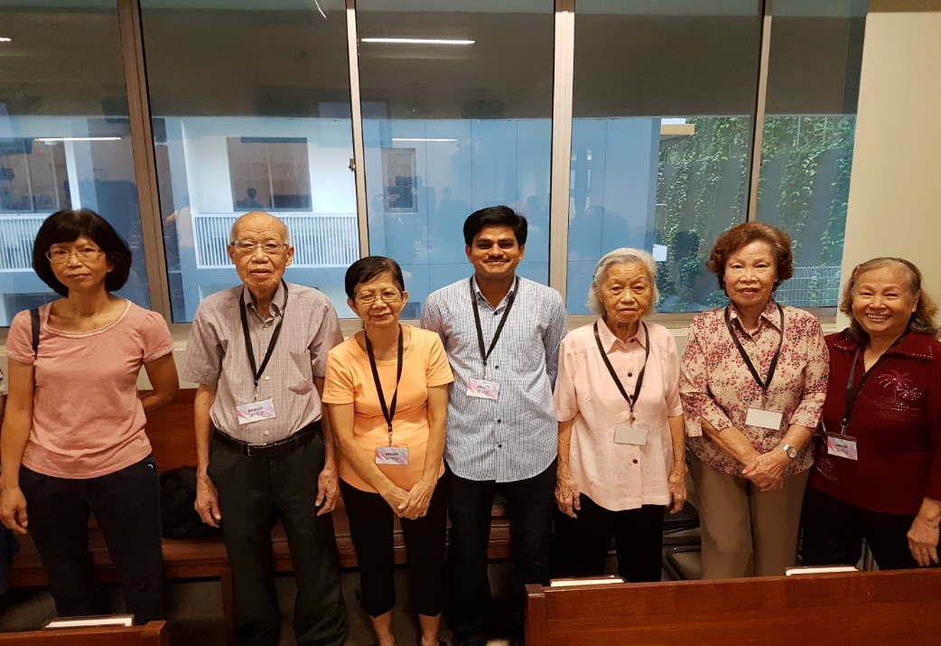

Ushers can make gospel friends feel most welcome. (Eric Chong, 2017)

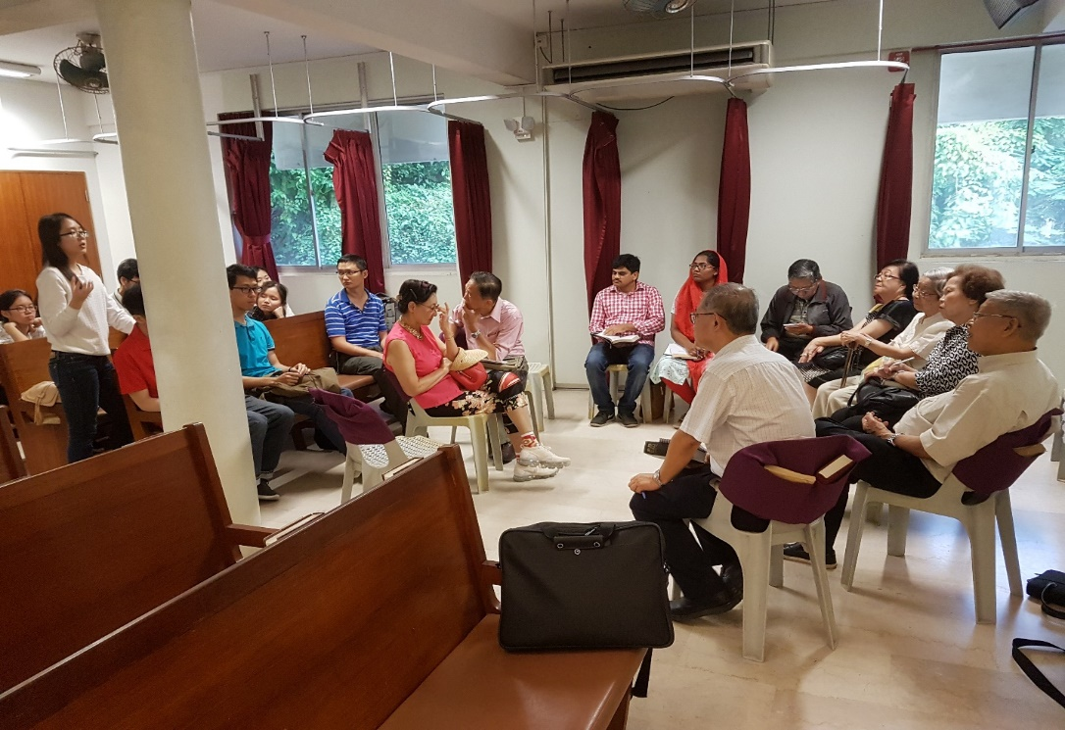

Feedback and ideas for the gospel meeting. (Eric Chong, July 2018)

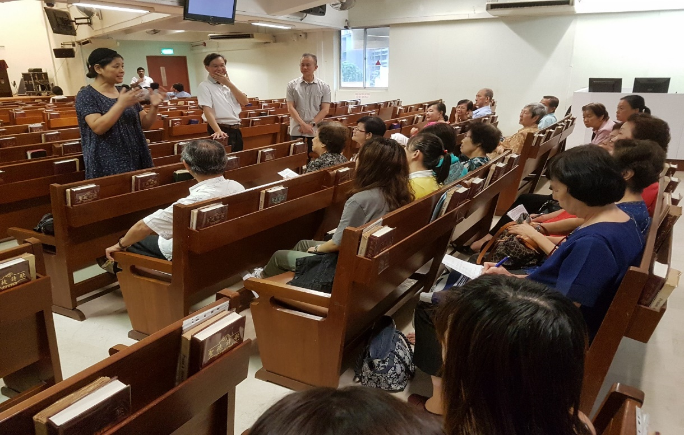

Share the gospel in daily living as and where we go. (Eric Chong, July 2018)

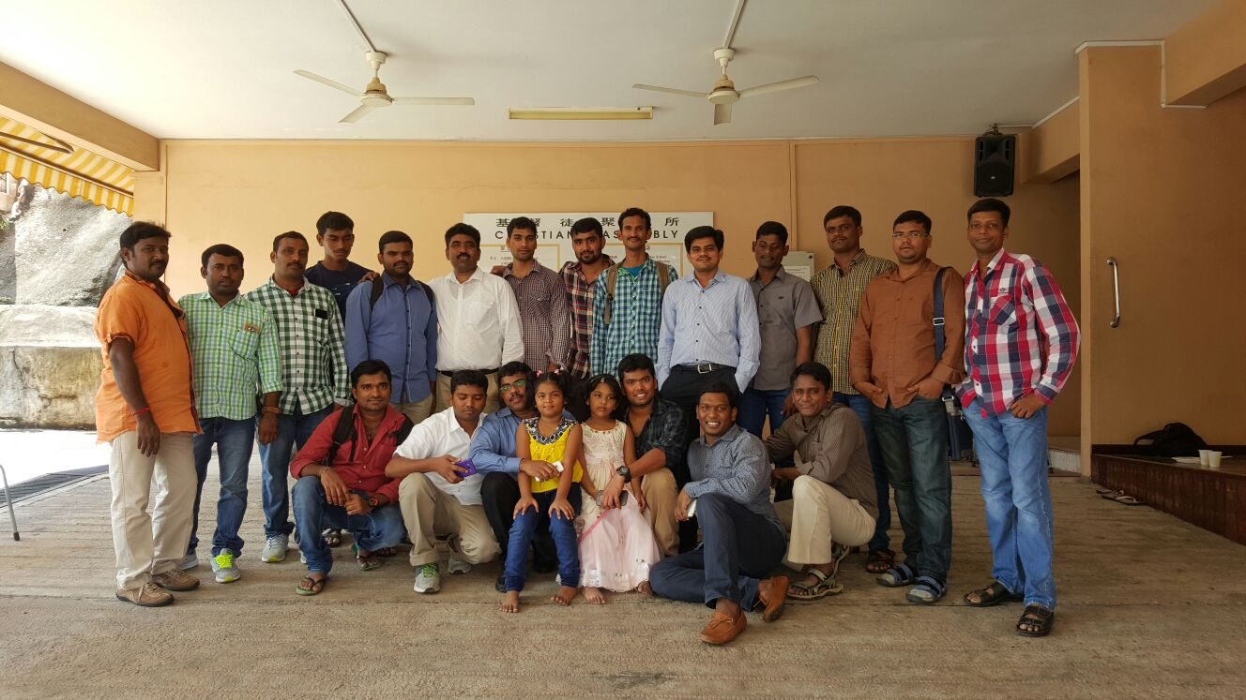

Indian gospel meeting in Wilkie. (Sagar, 25 Dec 2015)